npm Installation

Let’s now look at the steps to get npm installed. The official site for npm is <https://www.npmjs.com/>

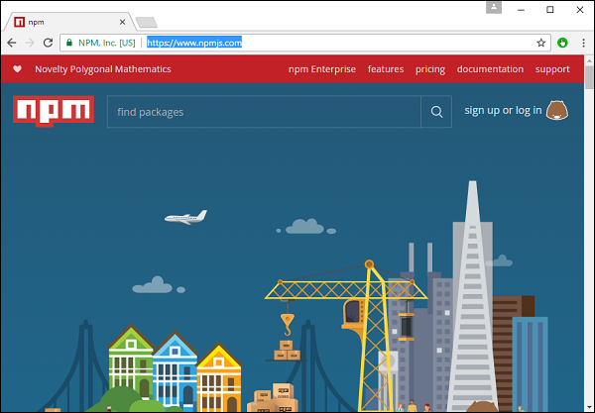

**Step 1** − Go to the “get stated with npm” section in the site.

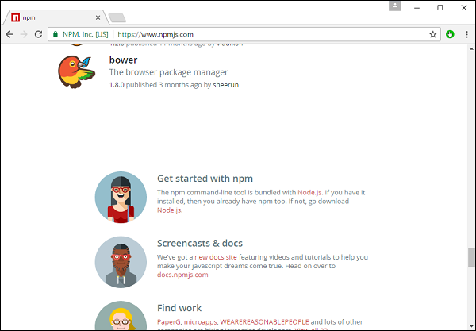

**Step 2** − In the next screen, choose the installer to download, depending on the operating system. For the purpose of this exercise, download the Windows 64 bit version.

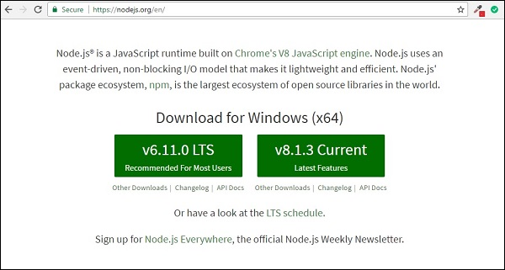

**Step 3** − Launch the installer. In the initial screen, click the Next button.

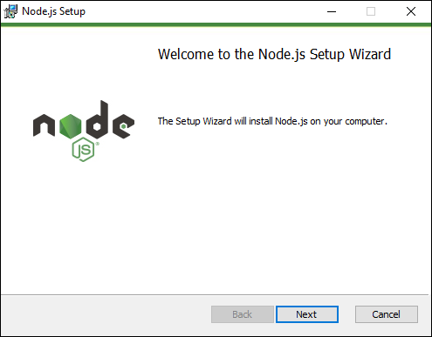

**Step 4** − In the next screen, Accept the license agreement and click the next button.

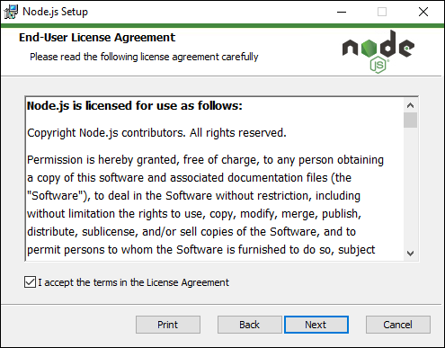

**Step 5** − In the next screen, choose the destination folder for the installation and click the Next button.

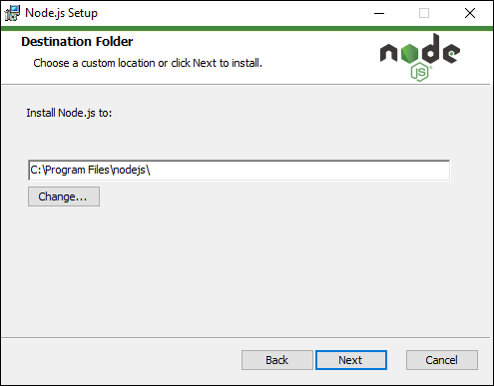

**Step 6** − Choose the components in the next screen and click the Next button. You can accept all the components for the default installation.

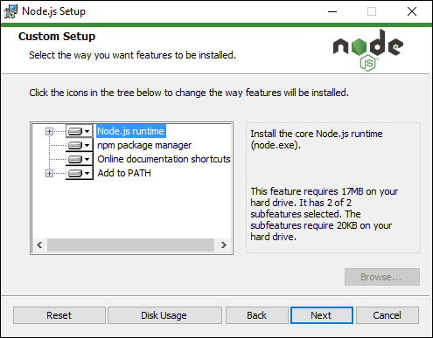

**Step 7** − In the next screen, click the Install button.

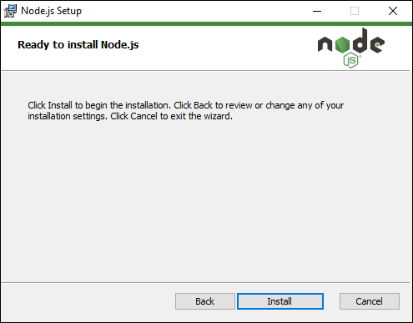

**Step 8** − Once the installation is complete, click the Finish button.

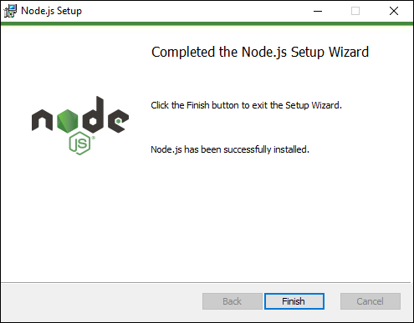

**Step 9** − To confirm the installation, in the command prompt you can issue the command npm version. You will get the version number of npm as shown in the following screenshot.

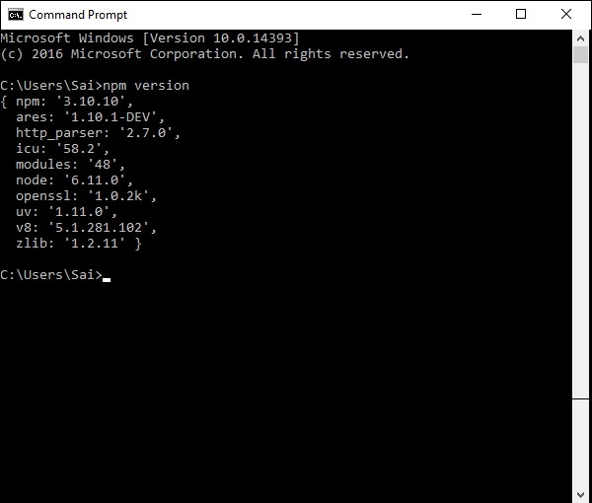

Installation of Visual Studio Code

Following are the features of Visual Studio Code −

* Light editor when compared to the actual version of Visual Studio.
* Can be used for coding languages such as Clojure, Java, Objective-C and many other languages.
* Built-in Git extension.
* Built-in IntelliSense feature.
* Many more extensions for development.

The official site for Visual Studio code is <https://code.visualstudio.com/>

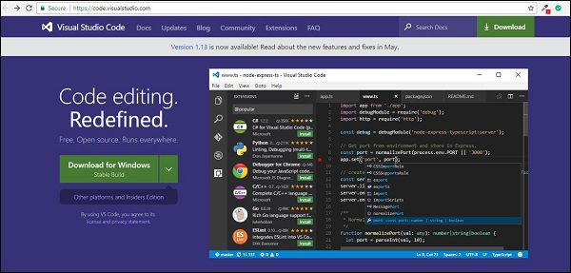

**Step 1** − After the download is complete, please follow the installation steps. In the initial screen, click the Next button.

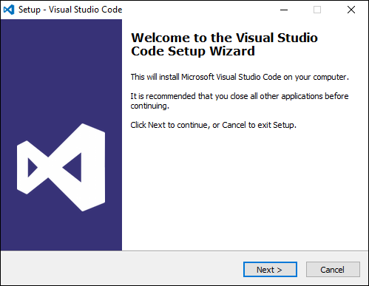

**Step 2** − In the next screen, accept the license agreement and click the Next button.

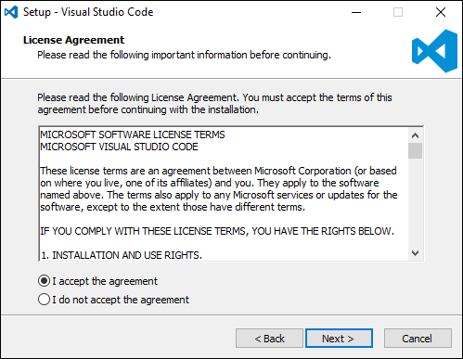

**Step 3** − In the next screen, choose the destination location for the installation and click the next button.

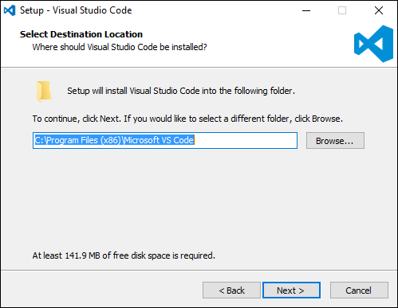

**Step 4** − Choose the name of the program shortcut and click the Next button.

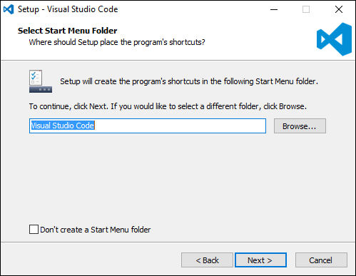

**Step 5** − Accept the default settings and click the Next button.

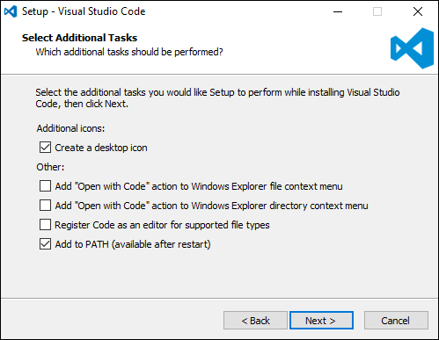

**Step 6** − Click the Install button in the next screen.

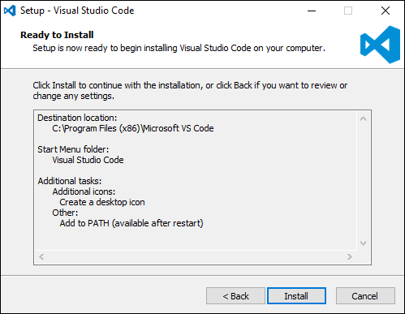

**Step 7** − In the final screen, click the Finish button to launch Visual Studio Code.

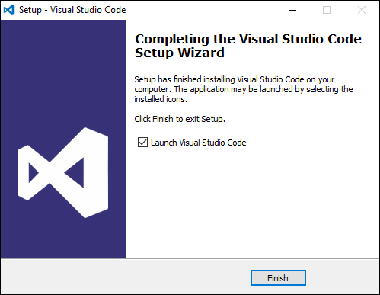

Installing Git

Some of the key features of Git are −

* Easy branching and merging of code.
* Provision to use many techniques for the flow of code within Git.
* Git is very fast when compared with other SCM tools.
* Offers better data assurance.
* Free and open source.

The official site for Git is <https://git-scm.com/>

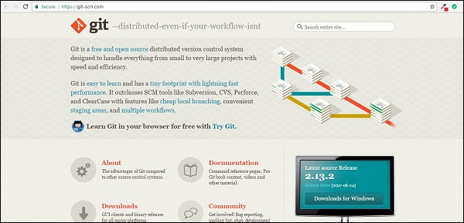

**Step 1** − After the download is complete, please follow the installation steps. In the initial screen, click the Next button.

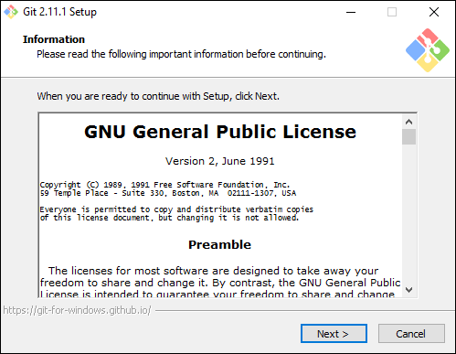

**Step 2** − Choose the components which needs to be installed. You can accept the default components.

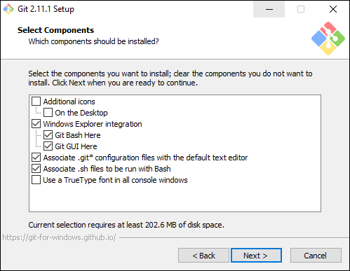

**Step 3** − In the next step, choose the program shortcut name and click the Next button.

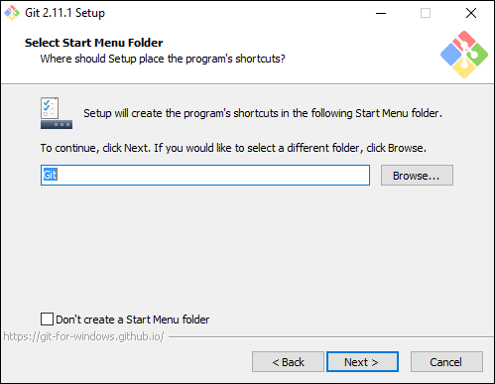

**Step 4** − Accept the default SSH executable and click the Next button.

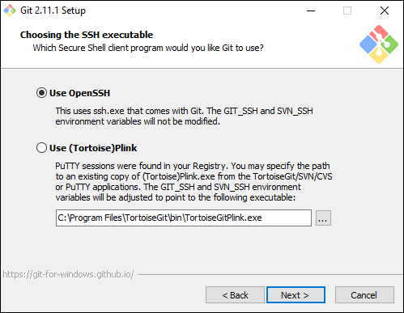

**Step 5** − Accept the default setting of “Checkout Windows style, commit Unix style endings” and click the Next button.

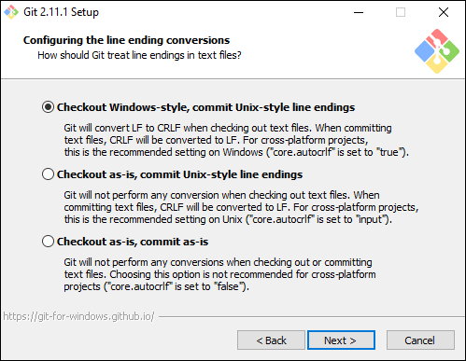

**Step 6** − Now, accept the default setting of the terminal emulator and click the Next button.

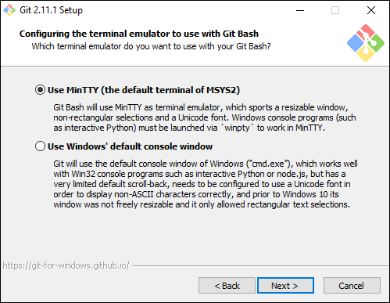

**Step 7** − Accept the default settings and click the Next button.

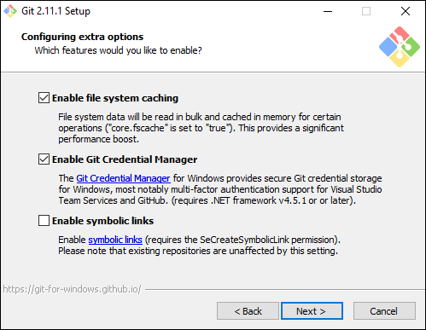

**Step 8** − You can skip the experimental options and click the Install button.

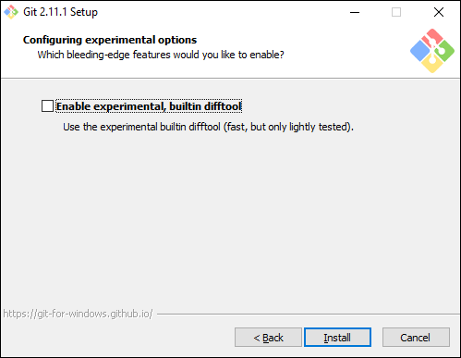

**Step 9** − In the final screen, click the Finish button to complete the installation.

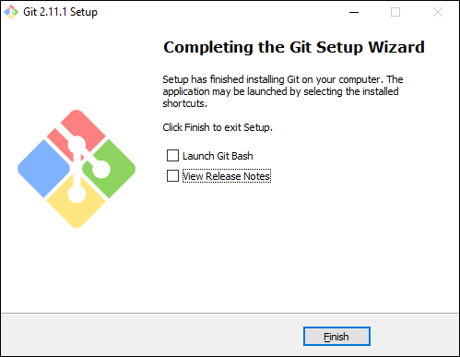

Install Angular CLI

npm install -g @angular/cli@version

**Updating Angular CLI**

Global update:

*npm uninstall -g*[*@angular/cli*](http://twitter.com/angular/cli) *npm cache clean  
npm install -g*[*@angular/cli*](http://twitter.com/angular/cli)*@latest*

*npm update –g @angular/cli(update npm)*